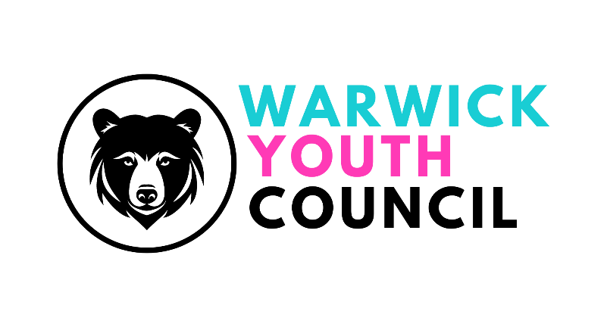
COMMITTEE MEETING
BALLROOM, THE COURTHOUSE, WARWICK -
SUNDAY 17th NOVEMBER 2024,
11am – 12pm
AGENDA
- Welcome
- Apologies
- Minutes from 9th September 2024
- Working Group project updates
- London trip feedback
- Remembrance Day representation feedback
- Saturday market stall – 7th December 2024 feedback
- Blogs update
- Recruitment of new members updates and discussion
- Finance update
- Guest speaker – Kelly Scott (Warwick Town Centre Manager) and Aaron Corsi (formerly Service Manager for Place, Projects, and Partnerships, Warwickshire County Council – now manager of Stratford BID)
- AOB

