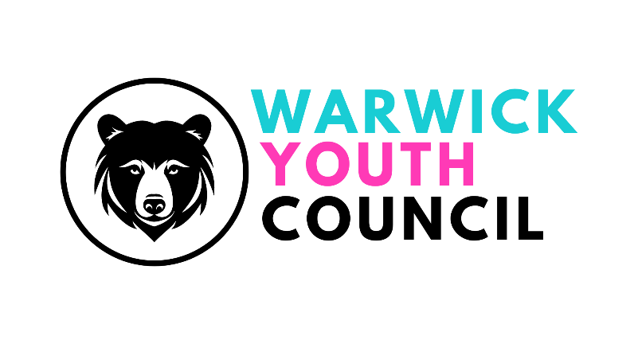
COMMITTEE MEETING
WARWICK SPACE, COTEN END, WARWICK -
SUNDAY 21st JULY 2024,
11am – 12pm
AGENDA

- Welcome
- Apologies
- Code of Conduct – to be agreed
- Social Media policy – draft
- Website for the Youth Council
- Working Group updates
- Budget update
- Guest – Councillor Jessica Harrison, Warwick District Council portfolio holder (including infrastructure, benefits, learning & development and marketing and communications)

- AOB

