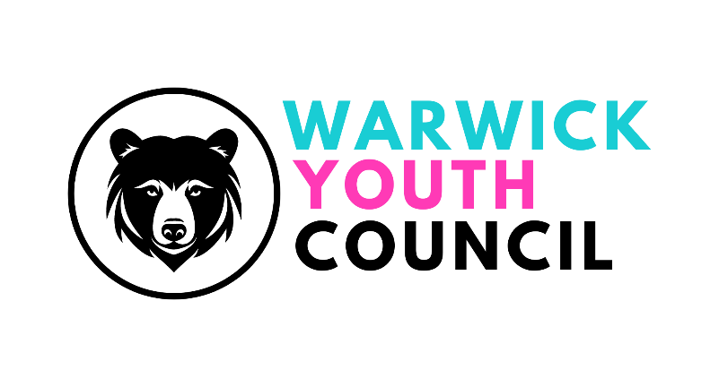
COMMITTEE MEETING
BALLROOM, THE COURTHOUSE, WARWICK -
SUNDAY 29th SEPTEMBER 2024,
11am – 12pm
AGENDA

- Welcome
- Apologies
- Minutes from 21st July 2024
- Social Media policy – draft
- Working Group project feedback
- Saturday market stall update
- Remembrance Day update
- Finance Officer report to WTC Finance & Policy Committee
- Deupty Chair report to full council
- Recruitment for new WYC members
- Parliament visit date update
- Website progress update
- Blogs creation for website and social media use update

- AOB

