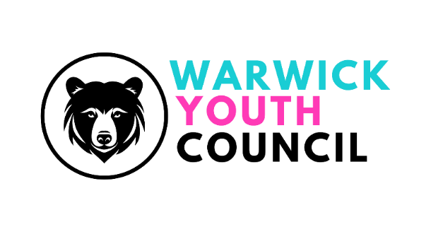
COMMITTEE MEETING
SUNDAY 17th NOVEMBER 2024, 11am – 12pm
THE BALLROOM,THE COURTHOUSE, WARWICK
Present: Sabrina Bailey (Chair), Kanish Kamalanathan(Vice-chair), Freya Balnaves, Lauren Griffiths, Vinci Chan, Siona Binu, Anna Barnes, Dexter Barrett, George Slatern, Maria Neacsu, Meg Pittam, Oliver Forster, Harry Whiston, Alexandria Fitches, Akshi Jeyasedan, Alden, Kavish Kamalanathan
Katherine Geddes (Asst Town Clerk, Warwick Town Council), Cllr Simon Pargeter, Cllr Oliver Jacques
Apologies: Alden Lee, Romeo Govindasamy, Cllr Cora Moynihan, Caterina Sgorbini, Cllr Eva Harrison, Marcos de Campos and Edward Thorpe.
NOTES
- Welcome – The Chair welcomed everyone to the meeting and thanked them for attending.
- Apologies - see above
- Minutes from 29th July 2024 – Accepted by all
- Working group feedback:
Campaign and fundraising: 600 responses have been received from the survey, still evaluating responses, and the conclusion report will be shared in the next meeting. Fundraising ideas discussed include a monthly walk for charities and a potential cake sale.
Environmental and Sustainability: Discussions revolved around where and when trees can be planted, potentially around primary and secondary schools in the area. Trees that do not require extensive care are preferred. Kanish will send letters to schools. Possibility of establishing a community garden was also raised. Mental Health and Wellbeing: Wellbeing sessions in different schools in the area were held, with around 30 participants in each session – they weren’t held – they were discussed. Activities included dog therapy with KHS's help, nature walks, yoga,
sound baths and counselling. The group will email MIND to find someone to lead the counselling session.
- Remembrance Day representation feedback
Thank you to all who were present
Very crowded but also very successful
- London trip feedback:
Overview of trip: Meeting with Warwick MP Matt Western at parliament, YC members asked a lot of meaningful questions including advice when speaking to the public. Members enjoyed a tour of House of Lords, but not House of Commons as it was being prepared for meetings. The group also participated in a scavenger hunt at the National Portrait Gallery and concluded by gathering outside Buckingham Palace. All members enjoyed the trip and found it useful.
- Christmas Stall representation feedback:
More helpers needed – some members signed up for the shifts on offer (8:30am – 11am, 11am – 1pm and 1pm – 3:30pm)
- Blogs update:
No one has contacted Harry yet.
Reminder that all committee members need to do a 30 second blog to be sent to Harry as soon as possible
- Recruitment of new members:
Brand new posters have been printed, members can share them around the school site
- Finance update:
Lauren gave an update on expenditure of Youth Council finances to date in this financial year. A full report can be found on the website (when it is complete) or in the Whatsapp group.
- Guest speaker:
Aaron Corsi (formerly Service Manager for Place, Projects, and Partnerships, Warwickshire County Council – now manager of Stratford BID)
Talked about Town centre management
Joined Warwickshire county council 10 years ago, main duty was originally to look after highways, roads and cityscape
Coordination and balance in town centre management – multi stakeholders
Foundation economy: Everything can be done within the town centre in 20 minutes – Warwick does that!
Kelly Scott (Warwick Town Centre Manager):
Raised questions to members:
What it brings the youth to the town centre? History in the town centre? Pocket parks? Would be helpful to do a walk around the town centre with WYC members to look at how they use the area.
- AOB:
Next meeting time Sunday 26th January 2025, venue to be confirmed, 10-12
Meeting closed at 11:58 AM

