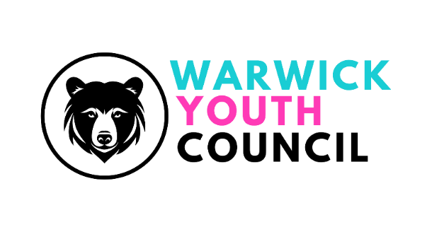
COMMITTEE MEETING
SUNDAY 21st JULY 2024, 11am – 12pm
WARWICK COURTHOUSE
Present: Kanish (Vice-chair), Lauren, Vinci, Harry, Caterina, Romeo, Freya, Akshi, Alden, Dexter, Kavish
Katherine Geddes (Asst Town Clerk, Warwick Town Council), Marcos Campos (Director
The Gap Community Centre), Cllrs Simon Pargeter, Eva Harrison
Apologies: Sabrina, Ed
NOTES
- Welcome - The Vice-Chair welcomed everyone to the meeting and thanked them for attending.
- Apologies - were noted from Sabrina Bailey and Edward Thorp – these were accepted.
- Minutes from 21st July 2024 – Accepted by all
- Working Group project feedback -
Events and projects: Gave an overview of Youth Showcase, evaluated contacts and costs
Campaign and fundraising: Survey shared, awaiting results to share and ready to start campaign when survey results are received
Environmental and sustainability: Brief overview of project – improve air quality in Warwick, date set around from now to Christmas during half term. Discussed parks, businesses and charities that the group would be working with. Simon raised concern about town clean, Katherine gave more information about the event and suggest that the E&S group should get involved after next meeting. The group agreed that this is a good idea.
Diversity and Inclusion: Project Include Reading - Discussed book club which would be organised by the group, lead asks everyone to talk to school to organise an assembly to spread the word.
Productivity in working groups – group leads agreed that the general atmosphere was good as most committee members are present
- Saturday market stall update – KG gave updates: Date changed to Sat 7 Dec (small business day). Members will need to engage different age/year groups with games, quizzes and prizes. There will be 3 shifts with 2 YC members on each shift. E&P committee suggested that there should be a contact list for people to write their names down.
KG suggests participants to dress festively, if more than two people are at the stall, can wander around and talk to others to increase community awareness of YC
KG asks members to check diaries whether they would be available. Information will be sent onto the WYC whatsapp group.
- Remembrance Day update – town council asks YC members to attend the remembrance service date is 10th Nov and participants will need to arrive at 9:45 AM.
- Finance Officer report to WTC Finance & Policy Committee – Lauren provided the income and expenditure sheet for all present members, gave an overview of the sheet – attached to this
KG suggests that the group needs to spend some money otherwise budget would be halved next year
E&P should be working on the youth showcase ASAP
Laura has agreed to attend the F&P committee
- Blogs creation for website and social media use update (agenda change as harry is leaving early) – KG gave information and every group will be creating a 30 second video
- Deputy Chair report to full council – Kanish giving report on 12 Dec, giving overview of what the WYC has done
- Recruitment for new WYC members – Will be trying to do so in future events
Diane has created posters and members are asked to decide on which one is better
Limited to year 7- year13 instead of the current age limit
- Parliament visit date update – No date decided yet, waiting for further update from parliament
- Website progress update – Vinci gave update on website, showcased main page of website and asked leaders of each committee to give a 50-100 word description of their committee. Pictures of members requested – members can opt out if they wish
- AOB
  - Date of next meeting – 17 Nov (Sun) in the courthouse 10-11 committee group, 11-12 general meeting
Meeting closed at 12:01

